Address by the Manchester Circle President Peter Purdue
The Casartelli Memorial Dinner, 25 February 2011

Each year the Manchester Circle remembers the foundation of our Association and honours Louis Charles Casartelli with a splendid memorial dinner. Dare I call this event a sort of canonisation by acclamation of Bishop Casartelli? Yes, I believe I dare, especially if we do it with our heads as well as our hearts.

Maybe one morning Louis Charles thought that Catholic laymen should be encouraged to join in an association of Chums – such a serious male organisation would be wonderful for his diocese. But I still ask myself, why? And what for?

Bishop Louis Charles knew what was going on in the world around him. He spoke several European languages as well as being a scholar in still-relevant matters Middle Eastern. He never abandoned his academic fervour … to his dying day.

I have chosen three pressure points to help understand the ‘why’ of our origins. The new bishop of 1903 would not have been far from the problems we face today: a blatant anti-Christian and anti-Catholic programme of public life, a marginalisation of religious people and their civic rights, and a deadly attempt to privatise higher education that will be seriously destructive of family formation and family economics.

The pressure points, then, that seem to me to have had great impact on Louis Charles:
1. The emergence of a critical Catholic social teaching.
2. The underlining of the role of the laity in the Church.
3. The fuller understanding of higher education in the Church’s mission.

Let me review these in historical order:

1. The fuller understanding of higher education in the Church’s mission
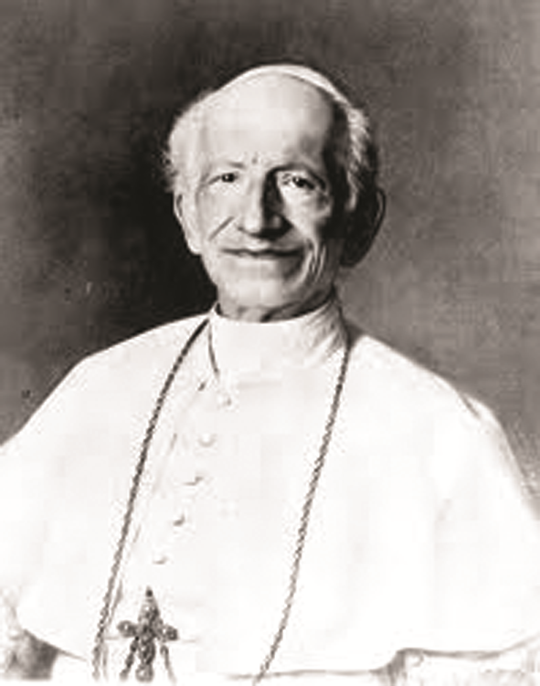
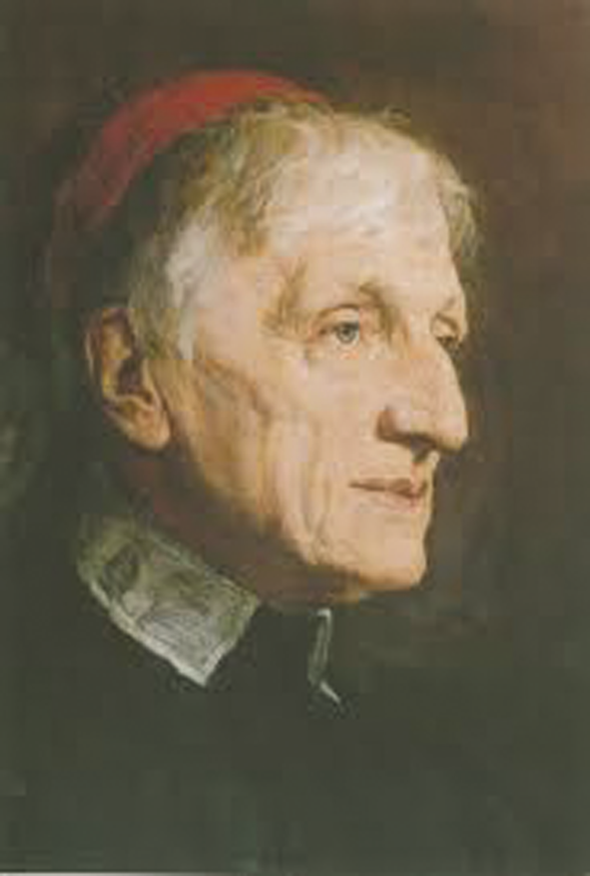
4 August 1878, the Encyclical Letter Aeterni Patris insisted on the restoration of a coherent and consistent Christian philosophy and its relationship with faith. The special role of St Thomas Aquinas, the Angelic Doctor, was spelt out in the expression of Christian theology, an importance that continues to this day. Many years before, Archbishop Vincenzo Pecci spent several weeks in England where he learned about the work and writings of a theologian he considered in the same vein as St Thomas. That same archbishop was elected as Pope Leo XIII in 1878. And soon afterwards, he inquired as to whether that same English theologian would accept a red hat? On 12 May 1879 John Henry Newman was made Cardinal Deacon of San Giorgio in Velabro (an recently restored gem of church, now well embedded in the Roman weddings circuit). After his conversion John Henry Newman fought tooth and nail for Catholic higher education. Louis Charles found himself continuing that battle all his life.

2. The underlining of the role of the laity in the Church
On 20 April 1884 another great Encyclical Humanum Genus confronted politics and society – how we should face an anti-Christian social setup. Catholics are not just to represent the Church’s teaching but to fight on the side of the poor and dispossessed. They should stand up to a Europe-wide, indeed worldwide, anti-Christian, and moreover an anti-human social agenda. In particular, Louis Charles he knew the country of Belgium extremely well. Belgian Catholics were encouraged to join organisations, sodalities and confraternities to make their voices heard and to foster the faith. In his own diocese the treatment of the poor and uneducated prompted Louis Charles to use whatever avenues he could to foster similar efforts among the laity.

The emergence of a critical Catholic social teaching
15 May 1891 – the Encyclical Rerum Novarum sees the Church facing facts-on-the-ground in people’s economic and social life. It is difficult to underestimate the importance of this encyclical. It continues to permeate a thoroughly Christian view of the world, and inspired Pope Benedict’s Caritas in Veritate as the very latest exemplar. But Vatican II’s Gaudium et Spes (The Church in the Modern World) puts the greatest seal of authority on the Rerum Novarum ideals. I believe that Louis Charles, and his fellow English bishops, took this encyclical extremely seriously, as it clearly spurred much of his pastoral work.

Papa Pecci was tireless in furthering the Church’s divine mission. As Leo XIII he was a super pope, intellectual yet practical, unstinting in fulfilling the First Vatican Council’s constitution on the Church, Pastor Aeternus and equally the other great constitution Dei Filius on revelation and faith, which he and his brother Giuseppe are said to have contributed. 85 Encyclicals came out of his 25 years as pope. And evidence is clear that his successor Giuseppe Sarto, St Pius X, saw himself as carrying forward that same agenda.

I believe that Louis Charles was also fundamentally influenced by Pope Leo’s efforts and thoroughly persuaded by it, and that our Association is born out of it.

I believe too that this agenda is still very much alive. My three points are as important as ever in this diocese and our Association.
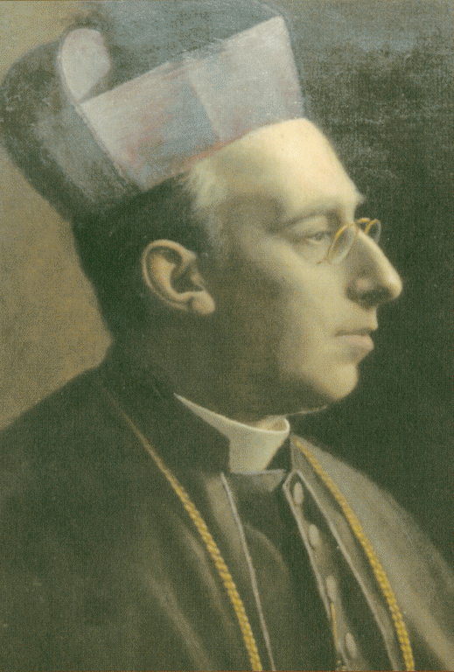
1. As a social society within the Church, our Association does and should reflect that stream of Christian social teaching.
2. The Association underscores the ideals of People of God and Universal Call to Holiness of the Second Vatican Council, and the subsequent teaching of Pope John Paul II.
3. Blessed John Henry has a permanent place in Association prayer; we are inspired by his desire for true understanding not only of our faith but also the world in which we live it.

Louis Charles passed on what he had received. And in his turn passed it on to John O’Donnell and his colleagues who took up the challenge and tried to stay true to it.

This manner of thinking keeps this Association important to the Manchester Circle. The job is still in hand.

Saint Louis Charles? – well, there is now an up-and-coming persuasion in Rome that miracles might be taken a bit wider than the curing of the very ill. Our Association and its ongoing genius, for me, might well represent a miracle sufficient to beatify Louis Charles. According to the rules we need just one more for his canonisation.

